**Lab 6**

Alec Wood

SDEV 300: Building Secure Python Applications

November 28th, 2021

|  |  |  |  |  |
| --- | --- | --- | --- | --- |
| Test Case | Input | Expected | Actual | Pass/Fail |
| Test 1 | Click Bases page  Click Eglin | Go to Wikipedia page for Eglin | Go to Wikipedia page for Eglin | Pass |
| Test 2 | Click Jobs page | Go to Jobs | Go to Jobs | Pass |
| Test 3 | Click Home | Go back home | Go back home | Pass |

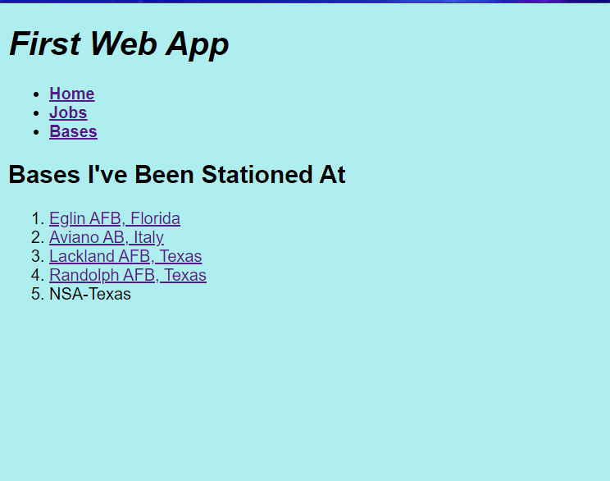

Bases Page

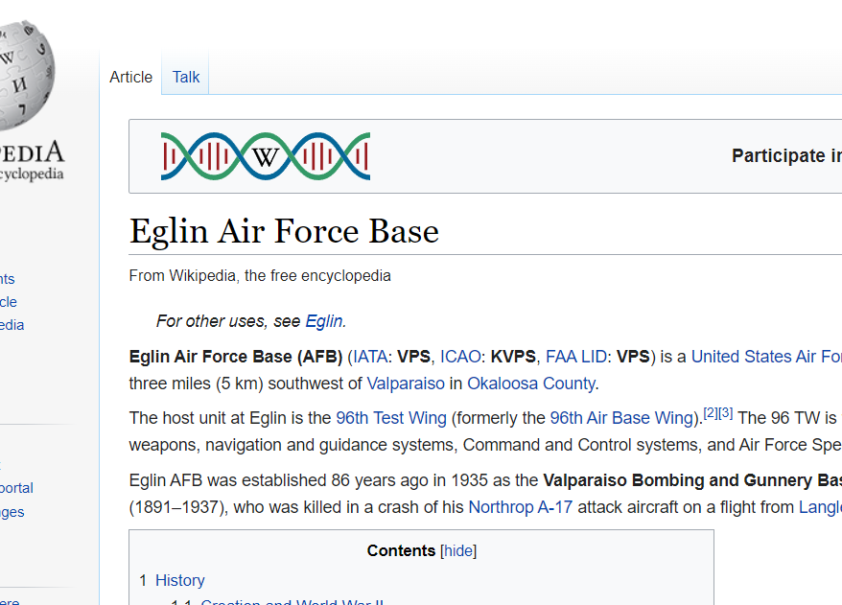

After clicking Eglin Link

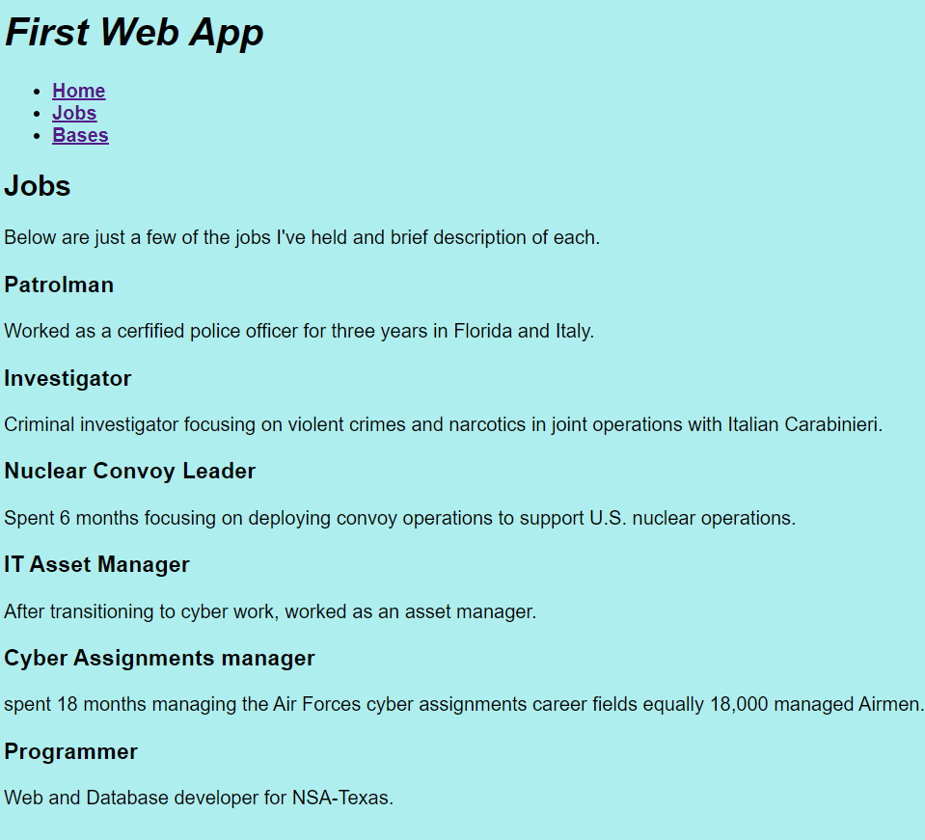

Jobs page

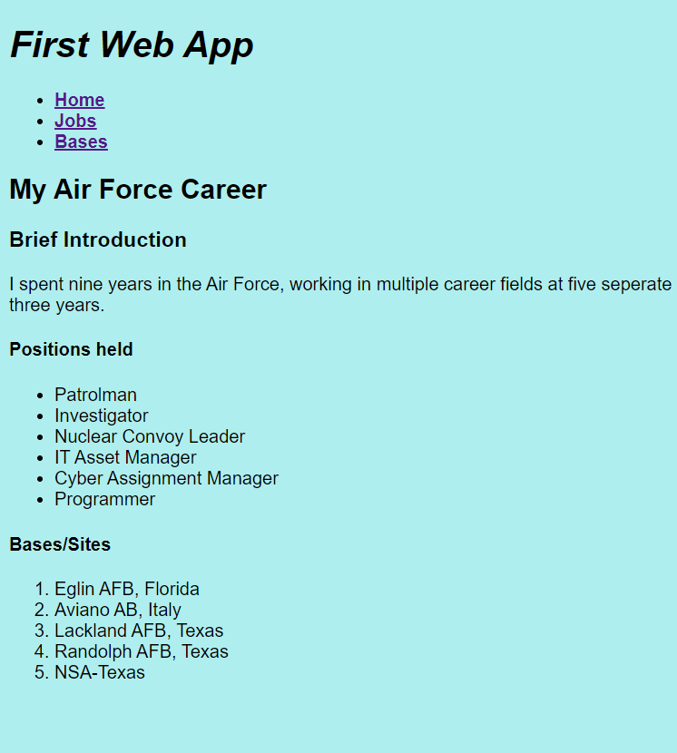

Home page

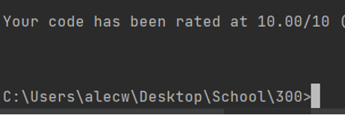

Pylint 10/10